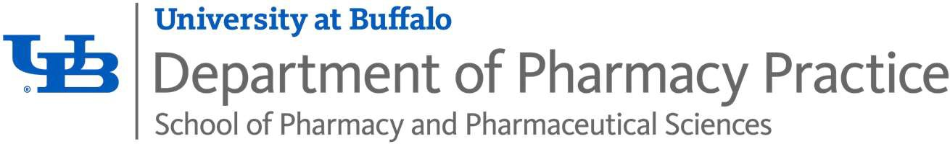

PGY1 Community-Based Pharmacy Residency
Program Purpose

To build upon Doctor of Pharmacy (PharmD) education and outcomes to develop pharmacist practitioners with knowledge, skills, and abilities as defined in the educational competency areas, goals, and objectives. Residents who successfully complete PGY1 residency programs will be skilled in diverse patient care, practice management, leadership, and education, and be prepared to provide patient care, seek board certification in pharmacotherapy (i.e., BCPS), and pursue advanced education and training opportunities including postgraduate year two (PGY2) residencies.

Overview of the Residency Program

Middleport Family Health Center and The State University of New York at Buffalo School of Pharmacy offer an ASHP/APhA Accredited PGY-1 Community Pharmacy Residency Program with a focus on community-based patient care. Strengths of this program include development and implementation of patient care services, advanced teaching and research opportunities, innovative transitions of care collaborative program, and robust ambulatory care practice collaborations embedded in local physician offices. The resident practices in an innovative and advanced environment where entrepreneurship is cultivated by preceptors and experienced ownership. Residents participate in a variety of disease state management and disease state education practice areas including medication therapy management, diabetes self-management education, hypertension management, and immunization delivery.

Description of the Practice Site
Middleport Family Health Center is part of an eight-store group of independent pharmacies and businesses located in the Western New York area. The pharmacy was acquired in 1983 by University at Buffalo School of Pharmacy alums Bruce Moden and Steve Giroux through the purchase of a chain store known as Peterson Drug. Since then, the Moden-Giroux organization has worked to establish a progressive patient-oriented pharmacy practice. The owners have continued to pursue this mission by incorporating advanced technology, utilizing an innovative pharmacy software system (PioneerRx), servicing assisted living facilities, offering a full line pharmacy complete with durable medical equipment and supplies, incorporating MTM and immunization services, developing clinical disease state management programs, establishing and growing physician collaborative practice agreements, and partnering with a local hospital to develop an innovative transitions of care program.

Required Learning Experiences
Orientation - is a required learning experience during the month of July at Middleport Family Health Center (MFHC). In this learning experience, the resident will review the policies and procedures of each practice site: MFHC, Transit Hill Pharmacy, Medina Memorial Hospital, and Primary Care of Western New York (PCWNY). The resident will review the University at Buffalo School of Pharmacy and Pharmaceutical Sciences Residency Program Resident Handbook as well as the Systematic Curriculum Design and Implementation (SCDI) for community- based residency pharmacy education and training with their preceptors. The schedule will be reviewed and the resident will be introduced to practice site staff at all locations. The resident will be introduced to the pharmacy software system, workflow and patient care activities at the practice sites.

Patient Care – Community Pharmacy is a required, longitudinal learning experience at the Middleport Family Health Center store. In this learning experience the resident will develop skills necessary to provide direct patient care services in a community pharmacy setting. The resident will learn how to identify and resolve medication-related problems; how to design, implement, and evaluate patient-centered medication action and monitoring plans; develop patient-centered relationships; establish relationships with other health care providers to collaborate in providing patient-centered care; effectively communicate with patients and providers; apply appropriate physical assessment skills; and comply with federal and state regulations in a community pharmacy setting.

Patient Care – Ambulatory Care is a required, longitudinal learning experience at Primary Care of Western New York. In this learning experience, the resident will develop skills necessary for patient-centered relationships and effectively communicate with patients and providers while providing pharmacy consultation services. The focus of this learning experience will be to provide direct patient care in collaboration with physicians and mid-level practitioners, with opportunities to manage a workload of regular follow up patients in addition to new patients referred to pharmacy services within the ambulatory care setting. Residents will spend one day per week at the primary care office, with the expectation that they begin and end their day on-site which is approximately 19 miles from primary site. Parking is available at no cost to the resident.

Practice Management and Leadership is a required, longitudinal learning experience at Middleport Family Health Center. In this learning experience, the resident will work with preceptors and ownership to develop skills associated with continuing professional development, commitment to the profession, time management, and organizational leadership. In addition, the resident will develop, implement, and evaluate a business plan for a new service or enhance an existing service in the community pharmacy.

Patient-Centered Dispensing and Counseling is a required, concentrated learning experience at Middleport Family Health Center. This learning experience will provide the resident with a formal and organized approach to preparing and dispensing medications as well as counseling patients as part of the dispensing process. The resident will develop knowledge and skill in various aspects of dispensing, including using appropriate techniques to prepare and dispense medications, resolving medication-related problems, understanding and improving the medication use process, utilizing medical informatics, providing effective patient counseling, and identifying additional patient care opportunities in the pharmacy workflow.

Transitions of Care is a required, longitudinal learning experience at Medina Memorial Hospital. Medina Memorial Hospital is a 30- bed critical access hospital, with an adjoining 28-bed long term care facility, located in Medina, NY. The focus of this learning experience is to improve the resident's communication skills with patients, caregivers, and other health care providers during care transitions and to help the resident apply clinical knowledge to direct patient care. Each rotation begins at the hospital, after which the residents return to the primary practice site, located approximately 5 miles away. There is parking available at no cost to the resident and no reimbursement for mileage during the course of this rotation.

Residency Project is a required, longitudinal learning experience at Middleport Family Health Center and the University at Buffalo School of Pharmacy and Pharmaceutical Sciences. In this learning experience, the resident will develop skills necessary to design, implement, and present a practice-based research project; and gain an understanding of the approval process necessary to conduct a research project and prepare a final manuscript.

Teaching and Education is a required longitudinal learning experience that serves to introduce the pharmacy resident to teaching within pharmacy academia. Pharmacy residents receive academic appointment as a clinical instructor with the University at Buffalo School of Pharmacy and Pharmaceutical Sciences. To compliment these teaching activities, each resident participates in a teaching certificate program and co-precepting pharmacy students during their IPPE / APPE rotations.

Additional Information
Eligibility: PharmD or equivalent experience; eligible for licensure in NYS; and completed application through PhORCAS. Immunization Training and Certification is also required.

PhORCAS: Letter of intent, curriculum vitae, three (3) references, and transcripts should be submitted electronically via PhORCAS

Program Duration: 52 weeks (July 1 – June 30) Number of Positions: 2

Salary and Benefits: Competitive salary; benefits package that includes health insurance, vacation and sick leave, paid holidays, travel support, stipend to attend professional meetings, online library, and computer privileges.

Application Deadline: January 5th

National Matching Service Code: 191315

Contact Information:

Ruth Ngwu, PharmD ruth.ngwu@middleportfamilyhealth.com Pharmacy Phone: 716-735-3261

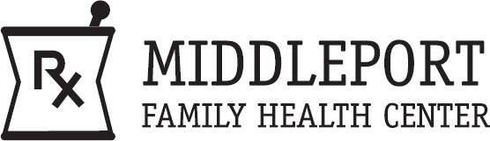
The PGY1 Community Pharmacy-Based Residency conducted by the UB School of Pharmacy and Pharmaceutical Sciences and Middleport Family Health Center is accredited with ASHP.

